Business Problem
NBA teams invest heavily in load management and sports science staff, yet they lack a simple, data-driven way to flag which specific players are entering a higher-risk window based on their own recent workload. Notably, the NBA's own analytics group examined roughly 150 players per season from 2014 to 2023 and found no significant correlation between game-participation frequency, schedule density, or cumulative participation and injury (Bontemps, 2024).
This project develops a machine learning model to predict elevated injury risk for individual NBA players based on recent in-season workload patterns with the goal of giving team performance staff an early, data-driven signal that complements existing load-management practices.
This project will address the following research questions:
- RQ1: Can a player's recent workload (rolling-average minutes, back-to-back frequency, days of rest, cumulative season minutes) predict elevated injury risk in the games that follow?
- RQ2: Which workload features are the strongest predictors of injury risk (recent minutes load, rest patterns, age, or position)?
- RQ3: Do the findings support or contradict the NBA's own conclusion that game frequency and schedule density are not meaningfully linked to injury risk?
Background
Injury risk in professional basketball has become an increasingly prominent analytics topic as teams weigh competitive performance against long-term player health. There are several prior works that inform this project. Studies of NBA injury incidence have tracked injury rates and severity across multiple seasons, providing baseline context for how common in-season injuries are league-wide (Bullock et al., 2022). Separately, the NBA's own internal analytics group publicly reported no meaningful link between game frequency, schedule density, and injury risk across nearly a decade of seasons. This conclusion runs counter to popular assumptions underlying load-management strategies.
More directly relevant to this project's modeling approach, Wang (2025) built a random forest classifier on publicly available box-score and injury data from 2010 – 2022, engineering sixteen workload and recency features and achieving roughly 69% correct classification of next-game injury risk using five-fold cross-validation. That work serves as a benchmark and methodological template for this project, though this project uses a narrower feature set focused specifically on workload and schedule variables rather than the fuller set Wang used. A separate survival-analysis approach to NBA injury duration and a load-management correlation study further informed the choice of workload variables engineered here.
Data Explanation
Three data sources were combined for this analysis, all sourced from Kaggle:
- NBA Injuries (2010 – 2020): 27,105 raw transaction records scraped from Pro Sports Transactions, with fields for date, team, player acquired, player relinquished, and a free-text notes field describing the transaction: https://www.kaggle.com/datasets/ghopkins/nba-injuries-2010-2018
- NBA Games: 26,651 game-level records (2003 – 2022) with final scores, shooting statistics, and a season label for each game: https://www.kaggle.com/datasets/nathanlauga/nba-games
- NBA Games Details: 668,628 player-level box score records (one row per player per game), including minutes played, points, and other box-score statistics, joined to game dates and seasons: https://www.kaggle.com/datasets/nathanlauga/nba-games
Because the injury dataset uses free-text “relinquished” and “acquired” fields rather than a clean injury flag, substantial data cleaning was required to derive a reliable injury label. Cleaning categories were identified iteratively. Reviewing the most frequent notes values surfaced entries describing rest days, personal reasons, and conditioning rather than genuine injuries. A keyword search for “coach” surfaced transactions mistakenly attributing head-coach medical leaves to a “player” field. Finally, cross-referencing the player field against team names surfaced one malformed record where a team name had been recorded as the player.
After cleaning, player names were matched between the injury dataset and the game log dataset using string matching, then improved via a normalization step that stripped periods from initials (for example, “C.J.” to “CJ”) and removed suffixes (Jr., Sr., etc). This raised the player-match rate from 94.3% to 97.0%. The remaining 3% consists largely of nickname variants (such as, “Nene Hilario”), spelling differences in international player names, and a small number of players with no recorded played games in the dataset.
Methods
The unit of analysis for modeling is the player-game: one row per player per game actually played (minutes > 0), restricted to the 2010 – 2019 seasons where both the injury dataset and game logs provide reliable coverage. All workload features were computed using only information available prior to each game (via a one-game shift before any rolling calculation), so that no feature could leak information from the game being predicted.
The target variable (injured_next_7d) is a forward-looking binary label: for each player-game, the player's next confirmed injury event was identified using a forward as-of merge, and the game was labeled positive if that injury occurred within 7 days after the game. This design directly reflects the project's business framing rather than a season-level “was this player ever injured” label.
Two classifiers were trained: a logistic regression baseline and a random forest classifier. Both used class_weight = "balanced" to account for the substantial class imbalance in the data without resampling the training data. Data was split by season rather than randomly (seasons 2010 – 2017 for training and 2018 – 2019 for testing) to ensure the model was evaluated only on games chronologically after anything it was trained on, avoiding the look-ahead bias that a random split would introduce. Model performance was evaluated using precision, recall, F1-score, and ROC-AUC rather than raw accuracy.
Analysis
After filtering to the 2010 – 2019 seasons and removing player-games with incomplete rolling-window history (1.9% of rows), the final modeling dataset contained an 8.3% positive rate for injured_next_7d. This is notably higher than the 4.2% positive rate observed before filtering to injury-covered seasons, confirming that including seasons outside the injury dataset's coverage would have diluted and mislabeled the target variable. The training set (2010 – 2017) contained 229,672 player-game rows (8.1% positive) and the test set (2018 – 2019) contained 55,249 rows (9.0% positive).
The following table summarizes model performance on the held-out test set:
Metric | Logistic Regression | Random Forest
Precision (Injury class) | 0.11 | 0.11
Recall (Injury class) | 0.48 | 0.59
F1-score (Injury class) | 0.18 | 0.19
Overall Accuracy | 0.61 | 0.55
ROC-AUC | 0.569 | 0.587

Both models performed modestly above chance, with the random forest achieving a better balance of precision and recall on the minority injury class. Neither model achieved strong discriminative power.
Cumulative season minutes was the strongest predictor in the random forest model, followed by the 10-game rolling average minutes and days of rest. Interestingly, cumulative season minutes carried a near-zero, slightly negative coefficient in the logistic regression model, suggesting the two models capture this variable's relationship to injury risk differently. This distinction could not be fully disentangled with the current feature set and is discussed further under Limitations.
Taken together, these results provide a qualified answer to the project's three research questions. In response to RQ1, recent workload does carry statistically detectable signal about near-term injury risk, but that signal is weak (AUC well below 0.70, generally considered a threshold for a clinically useful classifier). In response to RQ2, cumulative workload and rest patterns were the most informative features, while back-to-back scheduling contributed comparatively little. In response to RQ3, these findings are broadly consistent with the NBA's own published conclusion that schedule density and game frequency show little direct relationship to injury risk; this project's independently derived, weak-signal result reinforces that finding using a different data source and modeling approach.
Conclusion
This project set out to determine whether a player's recent workload could meaningfully predict near-term injury risk. The resulting models show a small but real predictive signal, but fall well short of the discriminative power needed for confident, individualized risk flagging. This outcome should not be read as a failed analysis. Rather, it is a legitimate and defensible research finding that aligns with independent conclusions published by the NBA's own analytics group. Workload and schedule variables alone appear to be an incomplete picture of injury risk, which is unsurprising given that injury is a multi-causal outcome influenced by factors well beyond playing time and rest, including player age, injury history, biomechanics, and chance. The models developed here are best understood as an early-stage screening signal rather than a deployable clinical decision tool in their current form.

Assumptions
- A 7-day forward window reasonably captures an actionable “at-risk” horizon for team performance staff; this threshold was not empirically tuned against alternative windows in this milestone.
- Back-to-back scheduling is accurately captured at the team level from consecutive game dates in the box score data, independent of which specific players were active.
- The 97% player-name match rate between the injury dataset and game logs is representative of the full population, and the unmatched 3% does not introduce systematic bias toward any particular type of player.
- Cumulative season minutes reset at the start of each new season and are not carried over from the prior season.

Limitations
- The injury dataset only reliably covers the 2010 – 2019 seasons, restricting the usable modeling window to ten seasons despite the game-log data spanning 2003 – 2022.
- The injury label lacks severity or injury-type granularity (e.g., ankle sprain vs. ACL tear are treated the same), which likely obscures differences in the workload-injury relationship across injury types.
- The feature set is limited to workload and schedule variables; no player-level biometric data (age, prior injury count, position, body composition) was available in the source datasets, and these are well-established injury risk factors absent from this analysis.
- Public injury-report data reflects only disclosed, reportable absences and may undercount minor or unreported injuries, introducing potential label noise in the negative class as well as the positive class.

Challenges
- Joining datasets from different sources required extensive, iterative data-quality investigation: distinguishing genuine injuries from rest days, personal absences, and conditioning entries required manually reviewing the most frequent free-text notes values rather than relying on a single field or keyword.
- A parsing artifact in the source data (a team name recorded as a player name) was only discovered by cross-referencing the player field against the list of team names.
- Multicollinearity between engineered rolling-window features (0.994 correlation between two variables) initially produced unstable, sign-flipping coefficients in the logistic regression model and required targeted diagnostic investigation to resolve.
- Severe class imbalance (roughly 1 injury-preceding game for every 11 non-injury games in the final modeling data) required imbalance-aware evaluation metrics and modeling choices rather than standard accuracy-based evaluation.

Future Uses
Beyond this project's current scope, the underlying approach has several plausible extensions:
- A real-time dashboard for team performance staff that flags players whose recent workload pattern resembles historical pre-injury patterns, used as one input among several rather than a standalone decision tool.
- Incorporation of wearable or tracking data (e.g., player-tracking speed and distance metrics) where available to teams, to move beyond box-score-derived workload proxies toward more direct measures of physical exertion.
- Use as a research tool for sports-science departments to test specific hypotheses about particular injury types or player subgroups, rather than a single undifferentiated injury label.

Recommendations
- Incorporate prior injury history as a feature in the next iteration of this model. It is one of the most well-established injury risk factors in the sports science literature and is conspicuously absent from the current feature set, despite being derivable from data already collected in this project.
- Add player-level context features where available, such as age, position, and years of NBA experience, to help the model distinguish individualized risk from leaguewide seasonal trends.
- Test alternative injury windows (e.g., 3, 5, 10, and 14 days) to evaluate whether a different forward-looking horizon produces a more actionable balance of precision and recall for the intended use case.
- Consider gradient boosting methods with formal hyperparameter tuning in a future iteration, alongside a time-series-aware cross-validation scheme.

Ethical Assessment
- Career and financial impact (Likelihood: Moderate; Impact: High): A model-generated “high risk” flag could influence a player's playing time, trade value, or contract negotiations if used without appropriate context. It should not be used as a sole or primary input into any such decision. Its near-term appropriate use is as one supplementary signal for medical staff, not as an independent basis for personnel decisions.
- Bias across positions or player roles (Likelihood: Moderate; Impact: Moderate): Players in heavy-minutes roles may be systematically flagged more often regardless of true individual risk, particularly given that cumulative season minutes was the most important feature and may partly reflect role rather than risk. Any deployment of this model should include an audit of error rates and flag rates across positions, ages, and roles before use.
- Data interpretation and reporting bias (Likelihood: High; Impact: Moderate): The underlying injury data reflects only publicly disclosed transactions and may not capture the full population of player health issues, including minor or unreported injuries. The extensive cleaning performed in this project improved label quality but cannot fully eliminate this source of noise, and any conclusions drawn from the model should be caveated accordingly.
- Potential for misuse (Likelihood: Low–Moderate; Impact: High): A team could be tempted to use risk scores to justify roster, playing-time, or compensation decisions beyond what the underlying data and model performance can support. This risk is somewhat mitigated in the near term by the model's modest performance, but any future, higher-performing iteration of this work should be accompanied by an explicit “intended use” and “not intended for” statement, and ideally reviewed by both data science and player relations/legal stakeholders before any operational use.

APPENDIX
EDA Visuals
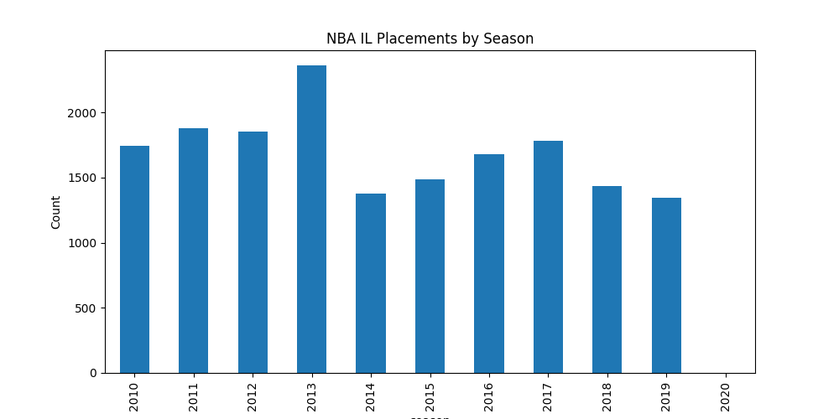

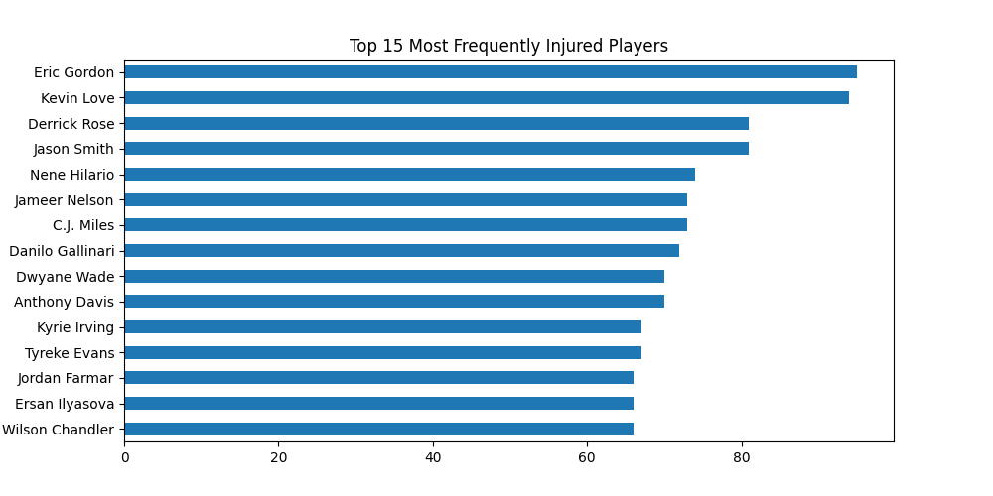
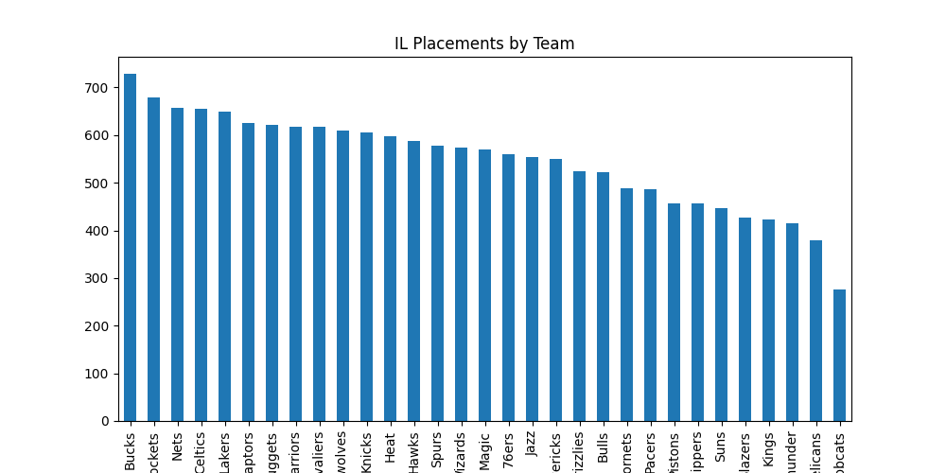

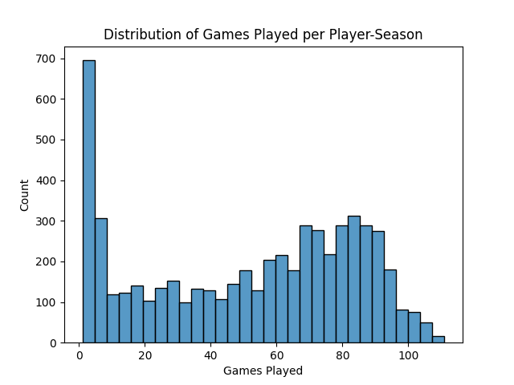

References
Bontemps, T. (2024, January 13). NBA report: No link between load management, less injury risk. ESPN. https://www.espn.com/nba/story/_/id/39288379/nba-report-no-link-load-management-less-injury-risk
Bullock, G. S., Ferguson, T., Vaughan, J., Gillespie, D., Collins, G., & Kluzek, S. (2021). Temporal trends and severity in injury and illness incidence in the National Basketball Association over 11 seasons. Orthopaedic Journal of Sports Medicine, 9(6). https://doi.org/10.1177/23259671211004094
Torres-Ronda, L., Gámez, I., Robertson, S., & Fernández, J. (2022). Epidemiology and injury trends in the National Basketball Association: Pre- and per-COVID-19 (2017–2021). PLOS ONE, 17(2), e0263354. https://doi.org/10.1371/journal.pone.0263354
Wang, E. (2025). Using injury-risk forecasting to quantify financial impact in the NBA. Wharton School, University of Pennsylvania. https://wsb.wharton.upenn.edu/wp-content/uploads/2025/12/WANG_Using-Injury-Risk-Forecasting-to-Quantify-Financial-Impact-in-the-NBA-1.pdf

Jupyter Notebook
Github link: https://github.com/cincodemarcho/dsc680-project1/blob/main/DSC680%20Project%201%20code.ipynb

10 Audience Questions and Answers
- Why should a team trust a model that’s only slightly better than a coin flip?
An AUC in this range tells us there's detectable structure in the data, just not enough to act on alone. Even modest signal can be useful as one input among several that a medical staff already weighs. The goal here was not to replace their judgment, it was to see whether workload data adds anything on its own.
- How do you decide what counts as an injury versus a rest day?
I started from the most frequent free-text entries in the "notes" field and categorized them. Entries like "rest (DTD)" or "placed on IL for personal reasons" were excluded as non-injury absences. I then found a second issue: a keyword search for "coach" revealed that a few head-coach medical leaves had been mistakenly logged under the player field. After removing both categories and one malformed row where a team name was recorded as a player, I was left with just over 16,900 confirmed injury events out of the original 17,560 raw entries.
- Why did you choose a 7-day window for ‘at risk’, and would a different window change the results?
Seven days was a reasonable starting assumption,. A shorter window, like three days, would give a tighter and more immediately actionable signal but fewer positive examples to learn from. A longer window, like 14 days, would give more positive examples but a fuzzier definition of "at risk." I've flagged testing multiple windows as a direct next step. It's possible a different horizon would shift both the positive rate and the model's performance.
- Why use logistic regression and random forest instead of a more advanced model?
I wanted an interpretable baseline before reaching for anything more complex. Logistic regression lets me look directly at coefficients and explain direction and relative weight to a non-technical audience. Random forest then lets me capture non-linear interactions without losing too much interpretability via feature importance. Gradient boosting is a logical next step, but I wanted to establish whether the signal existed at all with simpler, well-understood models first.
- What’s the single most important factor driving your model’s predictions?
Cumulative minutes played in the season by a clear margin in the random forest's feature importance. That said, I want to flag a caveat I found interesting: that same variable has an almost negligible coefficient in the logistic regression. My read is that cumulative minutes may partly be acting as a stand-in for "how far into the season are we" rather than purely reflecting an individual's excessive personal workload.
- Could this model unfairly affect a player’s contract or playing time?
That's a real risk, and it's why I included an ethical assessment as part of this work rather than treating it as an afterthought. A "high risk" flag could absolutely be misused to justify a benching or compensation decision if a team leaned on it too heavily. My position is that in its current form, it should only ever function as a supplementary input for medical and performance staff, not a standalone basis for a personnel decision.
- How confident are you that players from both datasets were matched correctly?
Fairly confident. After normalizing names, the match rate between the two datasets rose from 94.3% to 97.0%. The remaining 3% is mostly nicknames and international name spelling variants. I'm comfortable that residual gap doesn't introduce systematic bias toward any particular type of player.
- What data would have made this model meaningfully better?
Prior injury history. It's one of the most well-established risk factors in the sports science literature, and it's absent from this version of the model. Beyond that, player-level context like age, position, and years of experience would help the model separate individual risk from leaguewide seasonal patterns.
- Does this model account for the fact that some injuries are unrelated to workload?
No. Injury is a multi-causal outcome. Workload is one contributing factor among many, alongside biomechanics, contact, age, and plain chance. This model captured the workload-driven portion of that picture. The fact that its signal is weak is consistent with that scope, not a flaw in execution.
- If a team actually used this, what would you tell them to do with a ‘high risk’ flag?
I'd tell them to treat it as a conversation starter, not a conclusion. A flagged player should prompt a check-in between medical staff and coaching, not an automatic benching or roster move. Given where the model's performance currently stands, using it as anything more directive than that would be overstating what it can actually tell you.

